**Computer Network (Lab) 2020-21**

**Practice Assignment 1**

***Indicative Solution***

**Network Scenario:**

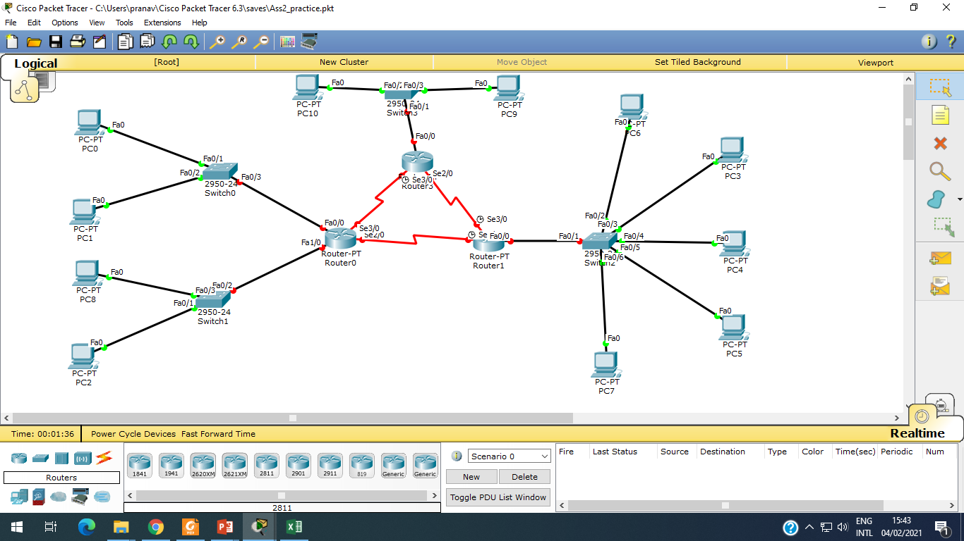

**Step 1:** Create a scenario in Packet tracer as per diagram.

**Step 2:** Set IP addresses to all PC (0-10)

|  |  |
| --- | --- |
| **PC0** | |
| IP Address | 10.0.0.2 |
| Subnet Mask | 255.0.0.0 |
| Default Gateway | 10.0.0.1 |
| **PC1** | |
| IP Address | 10.0.0.3 |
| Subnet Mask | 255.0.0.0 |
| Default Gateway | 10.0.0.1 |
| **PC2** |  |
| IP Address | 20.0.0.3 |
| Subnet Mask | 255.0.0.0 |
| Default Gateway | 20.0.0.1 |
| **PC8** |  |
| IP Address | 20.0.0.2 |
| Subnet Mask | 255.0.0.0 |
| Default Gateway | 20.0.0.1 |
| **PC3** |  |
| IP Address | 40.0.0.3 |
| Subnet Mask | 255.0.0.0 |
| Default Gateway | 40.0.0.1 |
| **PC4** |  |
| IP Address | 40.0.0.4 |
| Subnet Mask | 255.0.0.0 |
| Default Gateway | 40.0.0.1 |
| **PC5** |  |
| IP Address | 40.0.0.5 |
| Subnet Mask | 255.0.0.0 |
| Default Gateway | 40.0.0.1 |
| **PC6** |  |
| IP Address | 40.0.0.2 |
| Subnet Mask | 255.0.0.0 |
| Default Gateway | 40.0.0.1 |
| **PC7** |  |
| IP Address | 40.0.0.6 |
| Subnet Mask | 255.0.0.0 |
| Default Gateway | 40.0.0.1 |
| **PC9** |  |
| IP Address | 30.0.0.3 |
| Subnet Mask | 255.0.0.0 |
| Default Gateway | 30.0.0.1 |
| **PC10** |  |
| IP Address | 30.0.0.2 |
| Subnet Mask | 255.0.0.0 |
| Default Gateway | 30.0.0.1 |

**Step 3:** Configure Router 0 (from CLI prompt of Router 0)

Router>enable

Router#configure terminal

Enter configuration commands, one per line. End with CNTL/Z.

Router(config)#**interface FastEthernet0/0**

Router(config-if)#ip address 10.0.0.1 255.0.0.0

Router(config-if)#no shutdown

Router(config-if)#exit

Router(config)#**interface FastEthernet0/1**

Router(config-if)#ip address 20.0.0.1 255.0.0.0

Router(config-if)#no shutdown

Router(config-if)#exit

Router(config)#**interface Serial2/0**

Router(config-if)#ip address 192.168.0.253 255.255.255.0

Router(config-if)#no shutdown

Router(config-if)#exit

Router(config)#**interface Serial3/0**

Router(config-if)#ip address 193.168.0.253 255.255.255.0

Router(config-if)#no shutdown

Router(config-if)#exit

Router(config)#exit

Router#

**Step 4:** Configure Router 1 (from CLI prompt of Router 1)

Router>enable

Router#configure terminal

Enter configuration commands, one per line. End with CNTL/Z.

Router(config)#**interface FastEthernet0/0**

Router(config-if)#ip address 40.0.0.1 255.0.0.0

Router(config-if)#no shutdown

Router(config-if)#exit

Router(config)#**interface Serial2/0**

Router(config-if)#ip address 192.168.0.254 255.255.255.0

Router(config-if)#no shutdown

Router(config-if)#exit

Router(config)#**interface Serial3/0**

Router(config-if)#ip address 194.168.0.251 255.255.255.0

Router(config-if)#no shutdown

Router(config-if)#exit

Router(config)#exit

Router#

**Step 5:** Configure Router 2 (from CLI prompt of Router 2)

Router>enable

Router#configure terminal

Enter configuration commands, one per line. End with CNTL/Z.

Router(config)#**interface FastEthernet0/0**

Router(config-if)#ip address 30.0.0.1 255.0.0.0

Router(config-if)#no shutdown

Router(config-if)#exit

Router(config)#**interface Serial2/0**

Router(config-if)#ip address 194.168.0.252 255.255.255.0

Router(config-if)#no shutdown

Router(config-if)#exit

Router(config)#**interface Serial3/0**

Router(config-if)#ip address 193.168.0.252 255.255.255.0

Router(config-if)#no shutdown

Router(config-if)#exit

Router(config)#exit

Router#

**Step 6:** Configure routing table (static routing) in Router 0.

Router>enable

Router#configure terminal

Enter configuration commands, one per line. End with CNTL/Z.

Router(config)#ip route 40.0.0.0 192.168.0.254

Router(config)#ip route 30.0.0.0 193.168.0.252

Router(config)#exit

Router#

**Step 7:** Configure routing table (static routing) in Router 1.

Router>enable

Router#configure terminal

Enter configuration commands, one per line. End with CNTL/Z.

Router(config)#ip route 30.0.0.0 194.168.0.252

Router(config)#ip route 10.0.0.0 192.168.0.253

Router(config)#ip route 20.0.0.0 192.168.0.253

Router(config)#exit

Router#

**Step 7:** Configure routing table (static routing) in Router 2.

Router>enable

Router#configure terminal

Enter configuration commands, one per line. End with CNTL/Z.

Router(config)#ip route 40.0.0.0 194.168.0.251

Router(config)#ip route 10.0.0.0 193.168.0.253

Router(config)#ip route 20.0.0.0 193.168.0.253

Router(config)#exit

Router#

**Step 8:** Ping and tracert from PC1 to PC4 and vice versa.

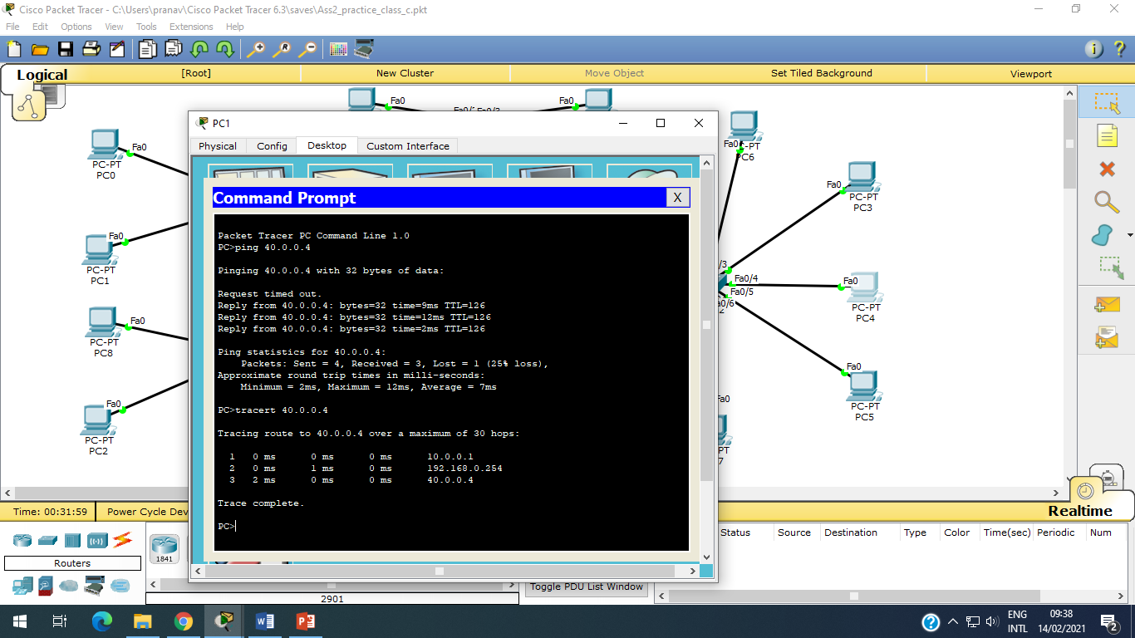

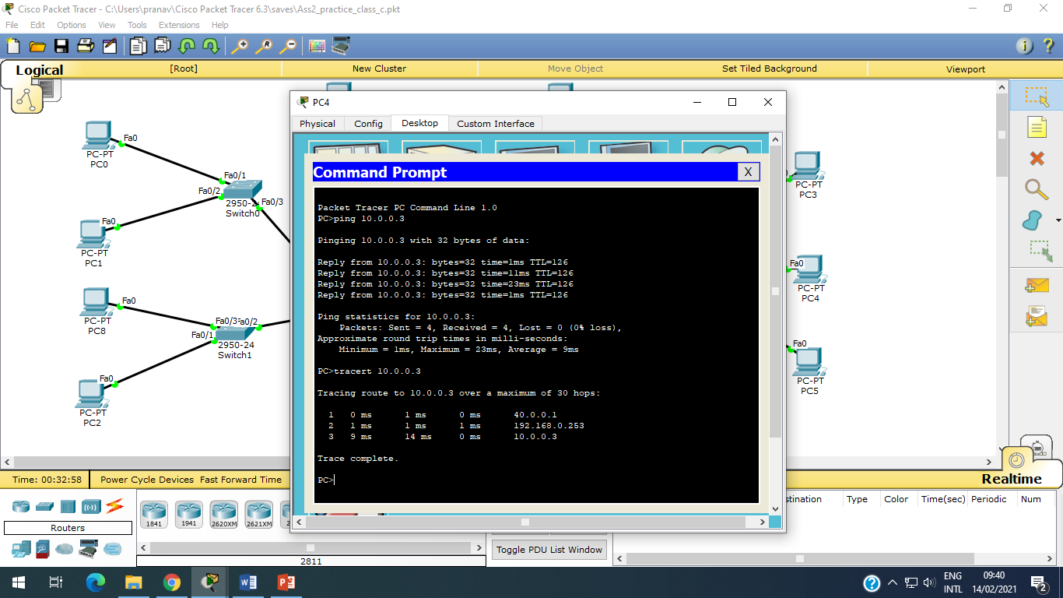

**Step 9:** Ping and tracert from PC2 to PC10 and vice versa.

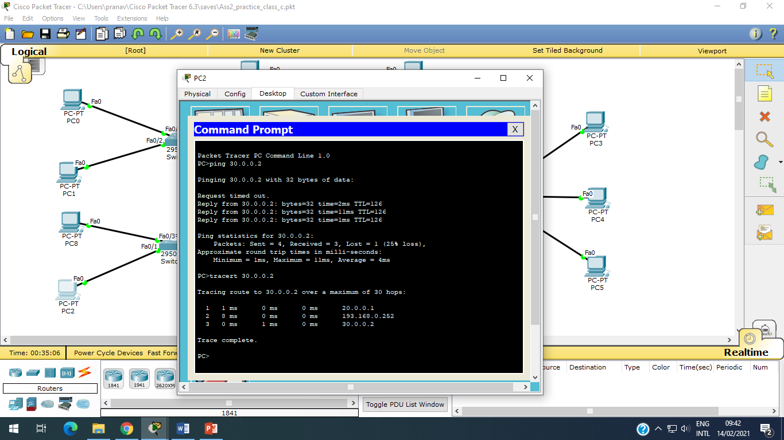

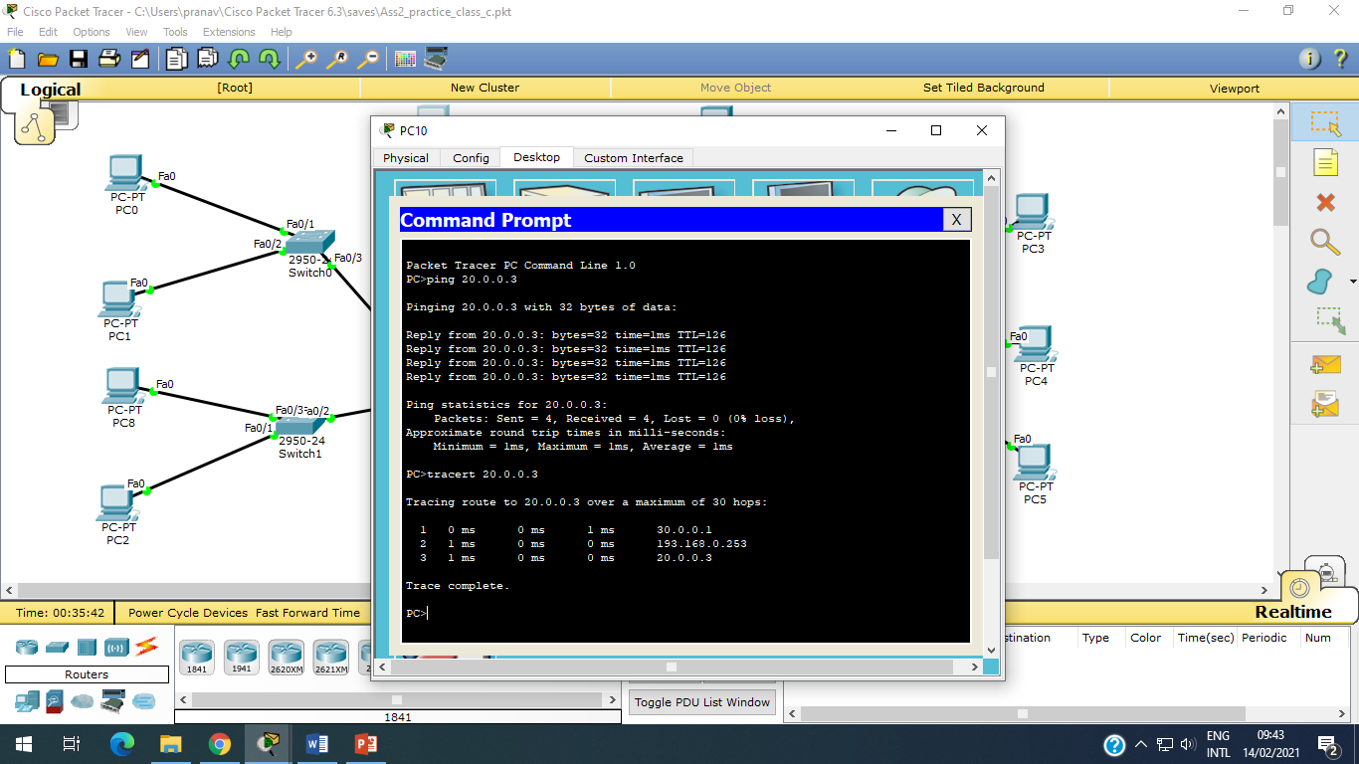

**Step 10:** Ping and tracert on all other machine, and check all connections are working or not.